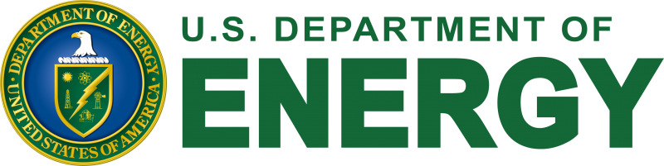

Press Release
News Media Contact: (202) 586-4940/DOENews@hq.doe.gov
For Immediate Release: June 17, 2022
U.S. DEPARTMENT OF ENERGY AWARDS $61 MILLION IN NUCLEAR ENERGY PROJECTS AT U.S. UNIVERSITIES, INDUSTRY,
AND NATIONAL LABORATORIES
74 Projects Accelerate R&D, Strengthen Infrastructure, Provide Career Opportunities
WASHINGTON, D.C. — The U.S. Department of Energy (DOE) today awarded more than $61 million for 74 nuclear energy projects across the country. The projects will support nuclear technology development, infrastructure improvements, and career opportunities at more than 40 U.S. universities. They will also help move the nation closer toward its goal of achieving net-zero emissions by 2050 by expanding access to nuclear energy—the nation’s largest source of clean power.
“These awards are an investment in both the next generation of nuclear technology and the next generation of scientists and engineers,” said U.S. Secretary of Energy Jennifer M. Granholm. “With funding from DOE, our nation’s universities will spur innovation and keep driving us toward our carbon-free future.”
The awarded funding is divided into three main buckets to support nuclear energy research efforts at U.S. universities in 29 states:
- Research and Development ($53 Million): Supports 49 awards and brings collaborative teams together to solve complex problems to advance nuclear technology and understanding.
- Infrastructure Improvements ($5.2 Million): Builds up scientific infrastructure and upgrades research reactors at 20 universities to expand the nation’s scientific capabilities and train the next generation of nuclear scientists and engineers.
- Career Development ($3.1 Million): Awards five university scientists for their outstanding commitment to science and education and supports their research activities through DOE’s new Distinguished Early-Career Program.
“As a former professor, I know firsthand the huge impact of stable support for emerging leaders in the scientific fields,” said Assistant Secretary for Nuclear Energy Dr. Kathryn Huff. “It allows early career researchers and educators to start solving big challenges right away, carry their work forward, and share that knowledge to make a real difference in the world.”

With these awards, DOE’s Office of Nuclear Energy has awarded more than $931 million to advance nuclear energy research and train the next generation of nuclear engineers and scientists since 2009. Please visit the Office of Nuclear Energy’s website to learn more about these activities, or visit these pages on Nuclear Energy University Program awards, Integrated Research Projects, Nuclear Science User Facilities awards, and Infrastructure awards.

###

