On Friday June 25, 2021 at about 0750 hours Deputy J. Medina was working overtime in our city (San Clemente) assigned to traffic enforcement. I heard Deputy Medina call out a car stop via his pac-set on Pico and the 5 Fwy. I continued to listen to Deputy J. Medina’s radio traffic. Dispatch came back to him and advised the registered owner was Gene James. I recognized the name as possibly San Clemente’s Interim Mayor. I waited for Deputy J. Medina to clear the car stop and advised him to call me asap.
When Deputy J. Medina telephoned me moments later, he confirmed the male subject he had pulled over was in fact Gene James, a representative of our city. Deputy J. Medina had advised me why he had conducted the car stop (running a red light off of the Fwy). Deputy J. Medina advised me that James slammed on his brakes, almost making Deputy J. Medina crash. Deputy J. Medina advised James to pull into the McDonalds Parking lot, and he complied.
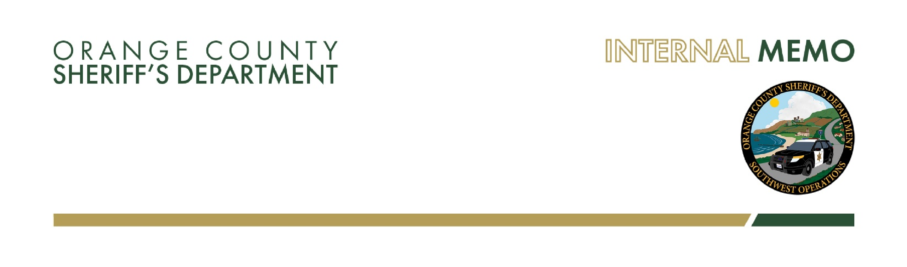
When Deputy J. Medina approached his vehicle, James was immediately on the defensive, making statements about knowing why he was pulled over, “Because of your boss, Captain Manhart.” Medina, advised James he did not know what he was talking about, but James continued to raise his voice at him. Ultimately James was issued a citation for the violation and released.

To:

Captain E. Manhart

From:

Sergeant M. Hudson

Date:

Friday June 25, 2021

RE:

Car stop

Sir,

I listened to Deputy J. Medina’s PVS audio. Deputy J. Medina was professional and explained in detail to James what he needed James to provide to him, and why he was stopped. The verbal communication with Deputy J. Medina was a play by play of what was recorded on his PVS. At no point did I hear Deputy J. Medina use profanity during the entire contact.
I have to commend Deputy J. Medina for his professionalism and demeanor. Listening to James yell at Deputy J. Medina and accusing him of pulling him over for ulterior motives, as well as having to be told multiple times to provide his insurance information, made me thankful the interaction was recorded.
I have sent you an email with this memo, Deputy J. Medina’s memo, and a copy of Deputy J. Medina’s PVS audio. Respectfully,

Sergeant M. Hudson # 6705

