Governor Nathan Deal
Chairman, Georgia Building Authority
Office of the Governor
206 Washington Street
111 State Capitol
Atlanta, Georgia 30334

July 20, 2015
Governor Deal,

I am writing in regards to the recent resolution adopted by the Georgia Building Authority to ban the use of Unmanned Aerial Vehicles, or drones, within a five mile radius of the State Capitol Building’s heliport, and within a five mile radius of the Governor’s Mansion.

In my capacity as the executive director of Drone Advocates for Public Safety, a non-profit organization dedicated to promoting the safe use of UAVs by fire/rescue, law enforcement and emergency management agencies; I take issue with the noticeable absence of any provision exempting these agencies from the ban on flying within the aforementioned zones.

Over three-quarters of a million people live in the Atlanta metro area “inside the perimeter,” and this population grows to over a million people on workdays.

The no-fly zone established by this ban encompasses approximately two-thirds of this area.

Therefore, this leaves the public safety community that serves this population unable to use a valuable tool that helps save money, save time, and potentially, save lives.

There are hundreds of police and fire departments across the country, many of them agencies we work with, using this technology safely and with the full permission of the Federal Aviation Administration.

One must simply look at recent news reports from around the country to find examples of fire/rescue and law enforcement agencies using UAVs for good.

In Joshua, Texas, for example, a fire department used a rescue rope attached to a UAV to help a couple that were stranded in their mobile home due to rapidly rising floodwaters.

Similarly, in Auburn, Maine, the fire department used a small UAV to drop life jackets to two young boys trapped in a raging river current.

In addition to these real-world examples, UAVs can be used in public service for assessing hazardous materials emergencies without putting rescuers’ lives in danger, monitoring large crowds for signs of distress, diagramming flame patterns for large-scale fires, and even finding downed rescuers using their body heat signatures.

In their use of UAVs, and as is clearly defined in their Certificates of Authorization from the FAA, certificated departments are in frequent communication with appropriate air traffic control authorities, regional FAA offices, and aircraft pilots alike.

These controls are in place to mitigate any potential safety hazards posed by flying UAVs in areas where manned aircraft may be present.

In light of these pre-existing mandatory safeguards, there is no reason why those public operators interested in using UAVs, flying under FAA-approved authorizations, should pose any more hazard to aircraft utilizing the Georgia State Capitol Heliport, or the heliport located at the Governor’s Mansion, than any other aircraft that is permitted to operate in that space.

In fact, given the tight restrictions outlined in all COA documents, including their use only during daylight hours, under 400’ above ground level and within visual line of sight of the pilot in charge, these aircraft pose an even lower risk than traditional manned aircraft.

As an organization dedicated to promoting responsible adoption and operation of UAVs among public safety agencies and their UAV pilots, we fully understand any security concerns the Georgia Building Authority may have regarding the hobbyist use of UAVs in the vicinity of the Capitol and the Governor’s Mansion; and to a lesser degree, concerns over commercial use; though these concerns may be alleviated by the exemptions that commercial operators are required to possess.

We believe that allowing public safety usage of these tools within this UAV ban zone is not only pragmatic but safe, and in the best interest of the citizens of Atlanta, and the State of Georgia.

Engaging potential stakeholders such as Atlanta Fire Department, Atlanta Police Department, Atlanta-Fulton County Emergency Management Agency, Georgia Department of Public Safety, Georgia State Patrol and our agency in discussions about how UAVs might be operated safely within these zones is absolutely essential in developing an understanding of the potential value of UAVs and their operations; and in devising considered operational guidelines.

I, for one, as a resident of this area, know that I would want those public safety agencies responsible for protecting me and my family to have the ability to use all of the tools at their disposal to save my life, limb or property.

I would welcome the opportunity to discuss this matter with you or any member of your staff, or of the Georgia Building Authority at your convenience.

Warmest Regards,

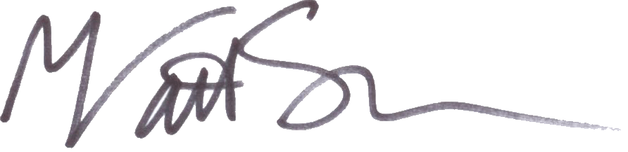

Matt Sloane
Executive Director
Drone Advocates for Public Safety
Matt@DroneAdvocates.org

President
Atlanta Drone Consultants LLC
Skyfire Consulting

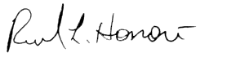  Lt. General Russel L. Honorè  US Army (Retired)  Commander, Joint Task Force Katrina | 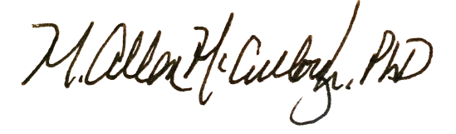  M. Allen McCullough, PhD, MSN, MPA,  MS, CEM, NRP, ENP/FNP-BC  Fayette County Fire Chief/ Director of  Public Safety (retired)  Advanced Practitioner  Schumacher Group  Emergency Medicine  Piedmont Newnan Hospital  Clinical Coordinator/Instructor  Emergency Nurse Practitioner Program  Emory University School of Nursing

