Who Brings the Magic to The Running Events?
By George Banker

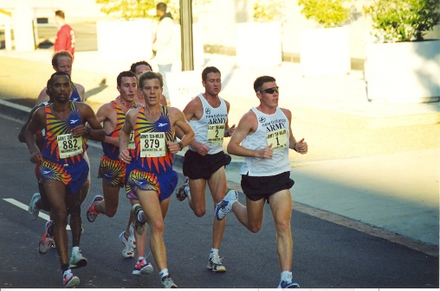
Andre Williams, Ray Pugsley, and Chris Graff battling with Dan Browne and Michael Bernstein of the U.S. Army. The battle was exciting, and one person was disappointed. the second-place finisher.
What makes one event stand out over another? Have you been to a race and left with a memorable moment? The magic comes from the first person you encounter, the VOLUNTEER. The volunteer sets the stage for you and how you will evaluate the experience. The volunteer will help you navigate a large packet pick-up area. How many times have asked, “Where do I get my number? The volunteer comes to the rescue. Can you imagine on a sweltering day, and you come up to a water table and no one is there. How many times have you come up and there are more hands holding cups and you can not make your mind up from whom take the cup? The volunteer makes your life seamless and all you must do is run.
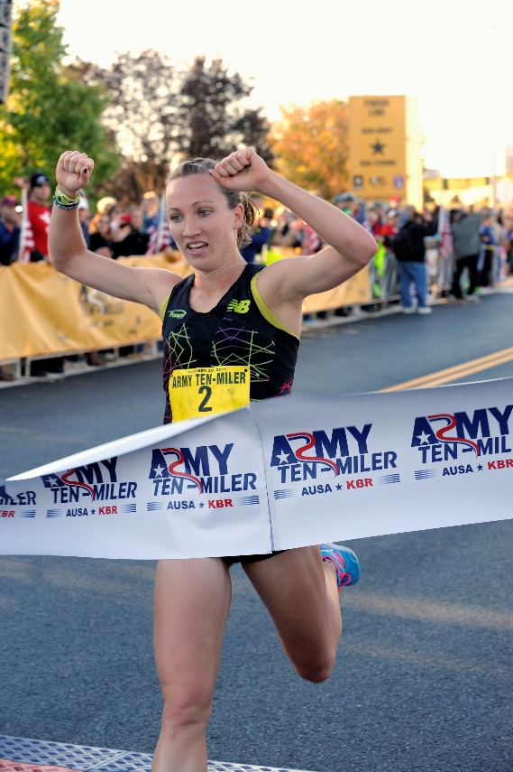
Do you run the race carrying the race map? If the volunteer were not on the corner the 5K could b a 10K because you took a wrong turn. How many times do you hear, “Thanks for being out here?”
The volunteer brings the magic with their dedication and the desire to have influence. When it is raining the runners will show up, but the volunteers have an option. The dedicated volunteer will be out getting wet with the runners. Take the same hot race and think about no volunteers and you must provide for yourself.
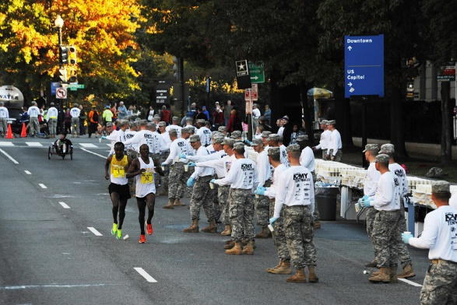

The volunteers in many cases arrive to a site before you and are there after you leave. They serve to clean up the aftermath of the party. They do not complain but feel they had influence in another person’s life. The volunteer will never know how many people they touch.

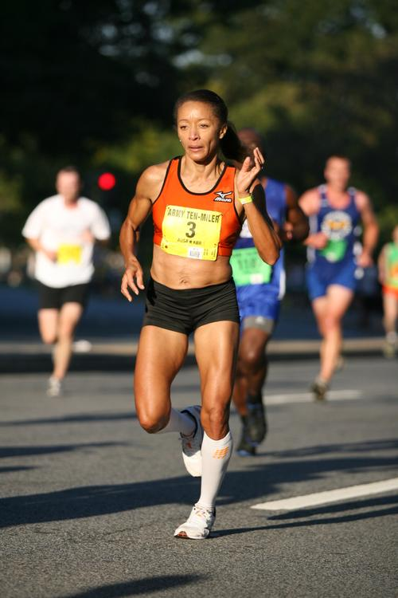
The volunteers are proud of what they do and how they do it. Each volunteer brings their personality to the race which can have the runners smiling in the middle of their pain as they compete against the clock. The first and the last runner benefit from the dedicated volunteer.
The volunteer do not receive a monetary reward but a personal feeling of satisfaction they are making that difference and bringing their own magic. There is no way to measure the warm feel the volunteer a feel at the conclusion of a race.
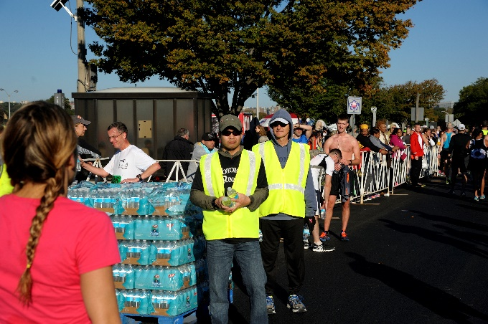
Every community race needs another set of hands and a smile. The volunteers are on the lookout for the safety of the runners and spectators. A runner does not slow down to let a pedestrian to cross between the runners. The volunteer will ask the pedestrian to wait before they cross.
The 38th Army Ten-Miler (October 7-9, 2022) is no different than any of the community races the small and large who value the volunteers and need their support. The Army Ten-Miler wants to tap into the magic to share with the runners.
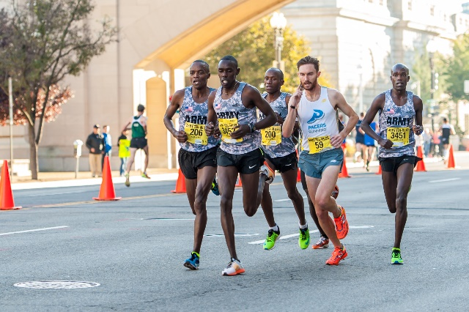
There are many reasons why a person volunteers for the Army Ten-Miler many of which are personal. There is a connection to the military, the sport of running, and just hanging out with friends and co-workers. Volunteering is a commitment to making a difference and creating memorable moments for our participants. Volunteering is not a one-time sacrifice of time but a mutual benefit. The Army Ten-Miler (ATM) volunteers have FUN while adding excitement, work FAST to make decisions, and are FOCUSED on the factors that achieve success.
The volunteers (soldiers and civilians) present the personality of the race. The volunteers are the first to meet the runners. The challenge is how to make the runners feel relaxed.

To register visit http://www.armyten.miler.com and follow the prompts. There are limited volunteer positions for groups of ten on race day. You can send an email to George Banker at george.r.banker2.naf@army.mil

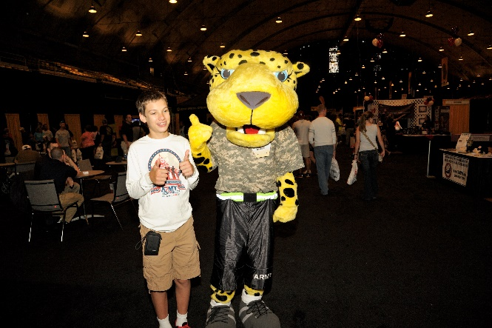

HOOAH!

