

Delights of the Senses: Seventeenth Century Dutch Art and Life

PRESS IMAGES

These images may be used by accredited media solely for purposes of publicity for the exhibition Delights of the Senses at the Albany Institute of History & Art. Images may not be altered, and must be accompanied by the captions as noted below.

Download these digital files HERE. For high-resolution images, or other urgent requests, please contact the Communications Office at communications@albanyinstitute.org or 518-463-4478. Please allow a minimum of one full business day for image requests.

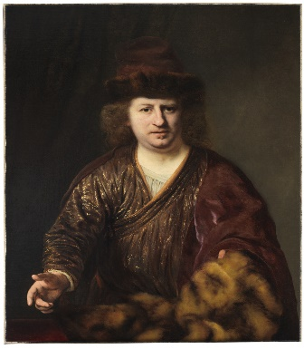

Man with a Fur-Trimmed Hat, Ferdinand Bol (1616–1680), oil on canvas, ca. 1646–48
The Leiden Collection, New York

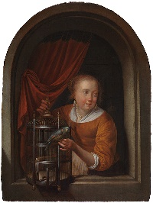

Young Woman in a Niche with a Parrot and Cage, Gerrit Dou (1613–1675), oil on panel, ca. 1660–65
The Leiden Collection, New York

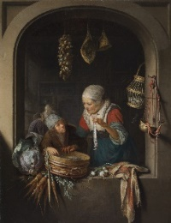

Herring Seller and Boy, Gerrit Dou (1613–1675), oil on panel, ca. 1664
The Leiden Collection, New York, GD-106

Young Man Smoking and a Woman Pouring Beer, Gabriel Metsu (1629–1667), oil on panel, ca. 1656–58
The Leiden Collection, New York

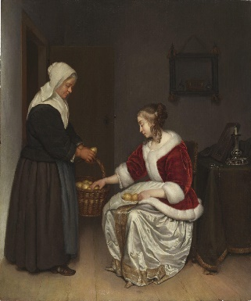
Two Women in an Interior with a Basket of Lemons, Caspar Netscher (ca. 1639–1684), oil on panel, ca. 1664–65
The Leiden Collection, New York

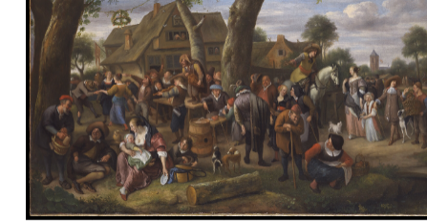
Peasants Merrymaking Outside an Inn (Previously Fair at Warmond), Jan Steen (1626–1679), oil on canvas, ca. 1676
The Leiden Collection, New York

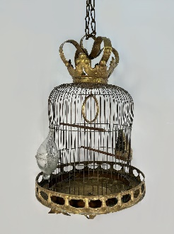
Birdcage, unidentified maker, the Netherlands, seventeenth century, brass
Historic Huguenot Street

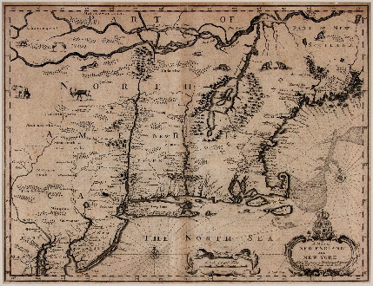
A Map of New England and New York
Engraved by Francis Lamb (fl. 1667–1701), London, England
Published by Thomas Based and Richard Chiswell, London, England 1676, engraving on paper
Albany Institute of History & Art, gift of the family of Michael S. Insel in his memory, LIB2021.75.5

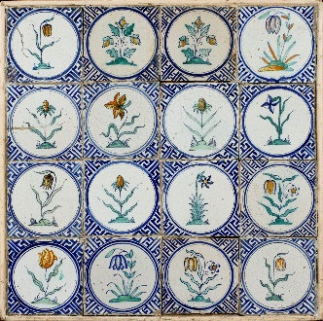
Floral tiles, unidentified maker, the Netherlands, ca. 1625, tin-glazed earthenware with polychrome decoration
Albany Institute of History & Art, gift of Mabel Brady Garvan, 1949.2.2

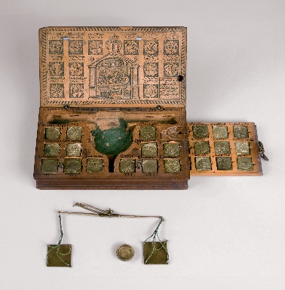
Gold-weighing scale, unidentified maker, the Netherlands, seventeenth century, wood, brass, paper
Friends of Historic Kingston

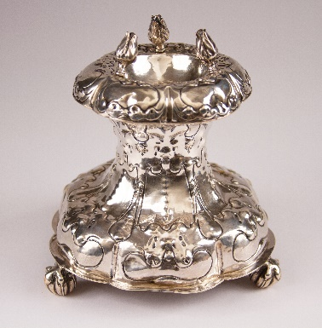
Standing salt cellar, attributed to Gaeff Meynertsz Fabritius (1602–1666), Haarlem, the Netherlands, 1652, silver Albany Institute of History & Art, gift of Leslie Stafford Crawford Hun in memory of her husband, Dr. John Gale Hun, 1964.13

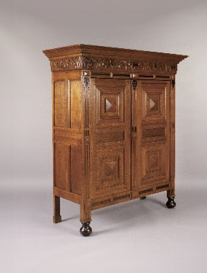
Kas, unidentified maker, the Netherlands, 1650–1670, oak with ebony
Albany Institute of History & Art, gift of George H. Way, 2019.7

###

