Scroll Down for Featured Food, Activities, & More
CHESAPEAKE CITY, NORTH EAST, ELKTON, PORT DEPOSIT

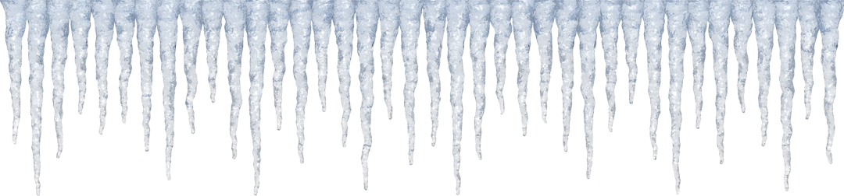
This Photo by Unknown Author is licensed under CC BY-NC
CHESAPEAKE CITY
Chilly Weather Dishes & Drinks:
Bayard House:
Maryland Crab Soup, Stuffed Anaheim Peppers, Seasonal Flatbread, Chicken and Brie Sandwich, www.bayardhouse.com

Cafe on the Bay:
Soup of the day, Winter Themed Specialty Coffees: Winter Berry, Peppermint Bark, Gingerbread, Creme Brulee, and Christmas Cookie, www.cafeonthebaymd.com

Chesapeake Inn:
Brick-oven Pizza, Crab Bisque, French Onion Soup, Crab Fondue, Molten Lava Cake; And winter drinks - Peppermintini, Bubbly Apple Cider, Spiced Eggnog, www.chesapeakeinn.com

Prime 225:
Baked Mac n Cheese, 225 Loaded Potato, Soup du-jour, and winter drink - Peppermint Chococello Martini, www.prime225.com

Rummur Lounge at Inn at the Canal:
Soup of the week, Hot Buttered Rum, Vanilla Spiked Cider, Spiked Dessert Bar featuring North East Chocolates, www.innatthecanal.com/bar

Schaefer’s:
Crab Dip, Cream of Crab Soup, Crab Melt, C & D Jambalaya,
www.schaeferscanalhouse.com

Chesapeake City “Winter Lights” Activities:

Shop along Bohemia Ave in specialty shops!

Winterfest of Lights and Resident Decorating Contest - Jan & Feb 2021

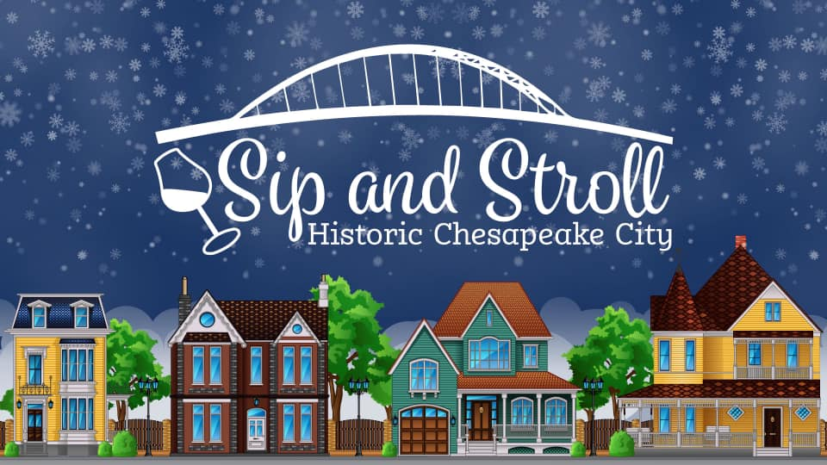
Sip & Stroll
Wander from porch to porch for tastings in the picture perfect historic district, Feb. 20, 5-8 PM, www.facebook.com/events/231222268366706

TOWN OF NORTH EAST
Chilly Weather Dishes & Drinks
Chesapeake Bay Coffee Company:
Donuts – Gingerbread, Peppermint Mocha, Hot Chocolate;
Hot Coffee – Ginger Snap, Frosty Mocha, Nutcracker;
Hot Chai – Jingle Spice, Snowball, Gingerbread
www.chesapeakebaycoffeeco.com

North East Chocolate Shop:
On- line orders in January, Shop open in February
Snow Bunnies Candy, Snow Caps Nonpareils, Ice Cubes Retro Candy
www.nechocolates.com

Port House Grill:
Pumpkin Bisque, Crab Bisque, Crab & Tomato Basil Cream Layered Soup, Shrimp Skewer, www.porthousegrill.com

Snatchers Creekside:
Homemade Crab Bisque, Jalapeno Poppers, Crab Pretzel, Wings & Rings, Mozzarella Moons,
https://www.facebook.com/snatcherscreekside/?ref=bookmarks

Steak & Main:
Bacon Mac & Cheese, Crab Risotto, Cream of Crab Asparagus Soup, Fried Brussels, Molten Lava Chocolate Cake, Bananas Foster, www.steakandmain.com

Woody’s Crab House:
Maryland Crab Soup, Crab Bisque, Twice Baked Potato, Old Bay Mac & Cheese, Warm Bread Pudding, www.woodyscrabhouse.com

North East “Winter Lights” Activities:

Shop along Main Street in antique and specialty shops!

Family Plush Snowball Fight on The Green!
Enjoy some good ole fashioned free family fun. Reservations on Saturdays beginning January 16th, www.northeastchamber.org

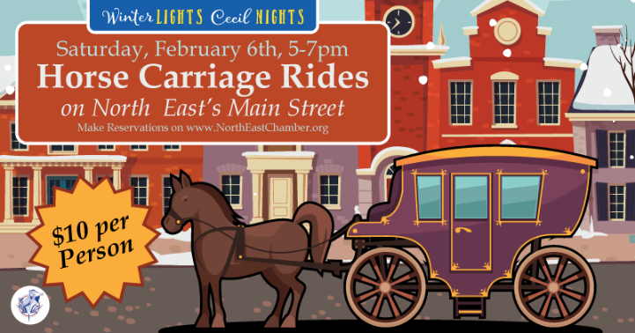
Horse & Carriage Rides
Ride through lighted downtown; Additional info and reservations, www.northeastchamber.org

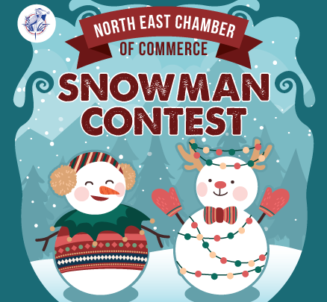
Snowman Contest
Submissions due late January www.facebook.com/northeastmd/events/?ref=page_internal

Snow Garden at Port House Grill
Jan. & Feb. - Hot chocolate, cider, mulled wine & more in a winter wonderland setting. We’re blowing snow (weather dependent) to offer a touch of the Alpine. Photo booth with authentic ski lift chairs. www.facebook.com/porthousegrill

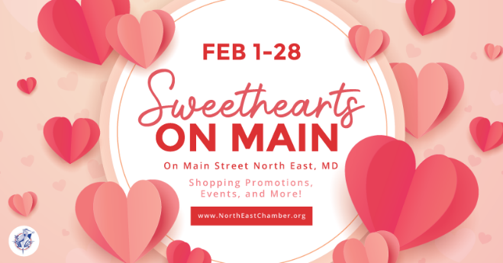
Sweethearts on Main
February 1 – 28
Shopping promotions and chances to win “Date-Night or Friend-Night for 2”
Sweethearts Crawl
Feb. 12 – 14, Strolling musicians, carriage rides, hot chocolate stations & more;
http://northeastchamber.org/sweethearts-on-main/

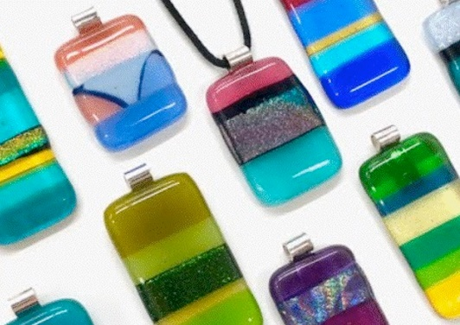
Glass Fusing Workshop
February 5th; Details and Registration
https://www.mdglasscreations.com/events/glass-fusion-workshop-beans-leaves-etc

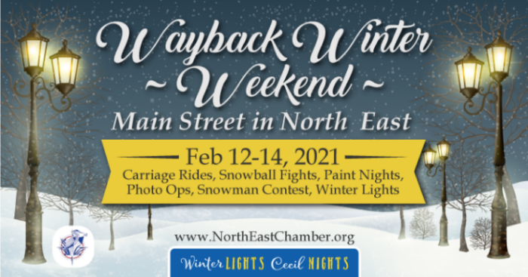
Way Back Winter :
Step back in time with activities, shopping, and dining along Main Street, www.facebook.com/events/3752377008119109

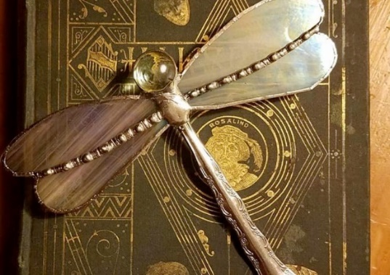
Dragonfly Stained Glass Workshop
February 24; Details and registration
https://www.mdglasscreations.com/events/stained-glass-dragonfly

Love Is In The Air Painting Class
February 13, Details and registration - https://www.beansleavesetcshop.com/apps/webstore/products/show/8188334

ELKTON
Chilly Weather Dishes & Drinks
C3ntral Tavern:
Featured Hot Soup, Central T. Pierogis, Truffle Parmesan Fries, Featured Mac n Cheese, Loaded Fries, www.c3ntraltavern.com

Elk River Brewing Co:
Bourbon Hot Toddy, www.elkriverbrewing.com

Spork:
Maryland Crab Soup, Tomato Bisque, and Steaming Hot Chocolate,
www.facebook.com/SporkCBM/

Elkton “Winter Lights” Activities
Shop along Elkton’s Main Street!

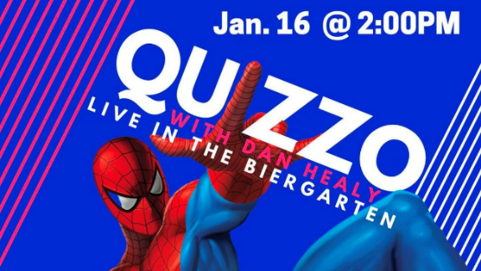
Quizzo Night & Fire Pits – Elk River Brewing
January 16 – 2PM; Bundle up for outdoor trivia with Spider Dan
https://www.facebook.com/elkriverbrewing/

New Year - New You:
Coupons and promotions from participating businesses to kick off your new year, https://www.facebook.com/events/777400836457341/

Emerging Artist Show
The Palette & The Page / January 5 - February 28
https://www.paletteandpage.com/special-exhibit-gallery-show/

For a winter line-up of Palette & The Page “Holistic Creativity” events:
https://www.paletteandpage.com/

Stupid Cupid
Jan 24 – Feb 14; Find at least 5 of Cupid’s arrows at participating locations in Elkton and enter for a chance to WIN a romantic dinner for two!
http://elktonarts.com/event/stupid-cupid-contest/

Art in Elkton Abounds:
Stupid Cupid Art Exhibit – Cecil County Arts Council
Feb 5 – 28; Art exhibit filled with love and light
https://www.cecilarts.org/events/stupid-cupid-exhibit/

The Palette & The Page Annual Art Show
Feb 5 – 28 - Creating Art During the Time of COVID;
https://www.paletteandpage.com/events-and-exhibits/list/

TOWN OF PORT DEPOSIT
Chilly Weather Dishes & Drinks:
Cool Beans:
Warm Up Your Belly Soups – Love Ya Lentils, Not Chilly Anymore Chili, I Love MD Crab Soup; And winter drinks – Winter Lite White Hot Chocolate, Peppermint Port, Winter Dream Steamer, www.coolbeansportdeposit.com

Mildred & Co:
Featured Hot Soups, Winter-Dogs (hot dogs) and Winter Latte’s - Maple, Cinnamon, Eggnog, White Chocolate Mint, & More, www.mildredsportdeposit.com

Granite Run Tap Room
Cheryl’s MD Crab Soup, Hunter’s Pie, Open Face Hot Turkey Sandwich, Guinness & Onion Mussels, 2lb Pretzel & Crab Dip, Cozy Ol’ Fashioned, Granite-tini, Moscow Yule, www.facebook.com/GraniteRunTaproom/

Port Deposit “Winter Lights” Activities:

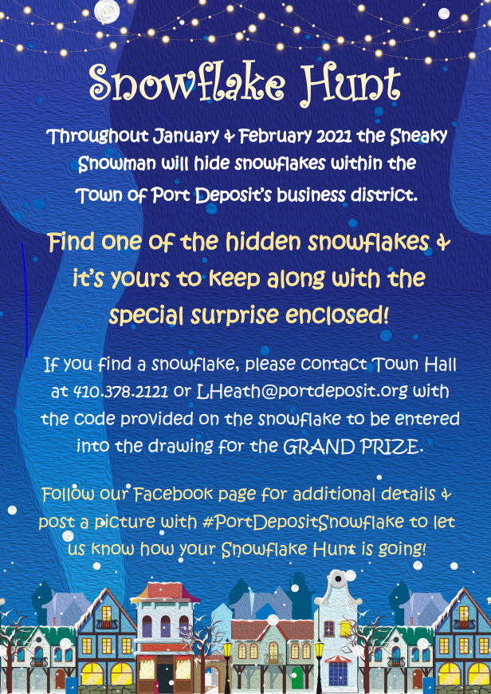

Snowflake Hunt:
The Sneaky Snowman is hiding snowflakes around town for you to find. https://fb.me/e/LU2WPxhY

